THE D STREET TRAIN SHOW SEPTEMBER 12th, 2026
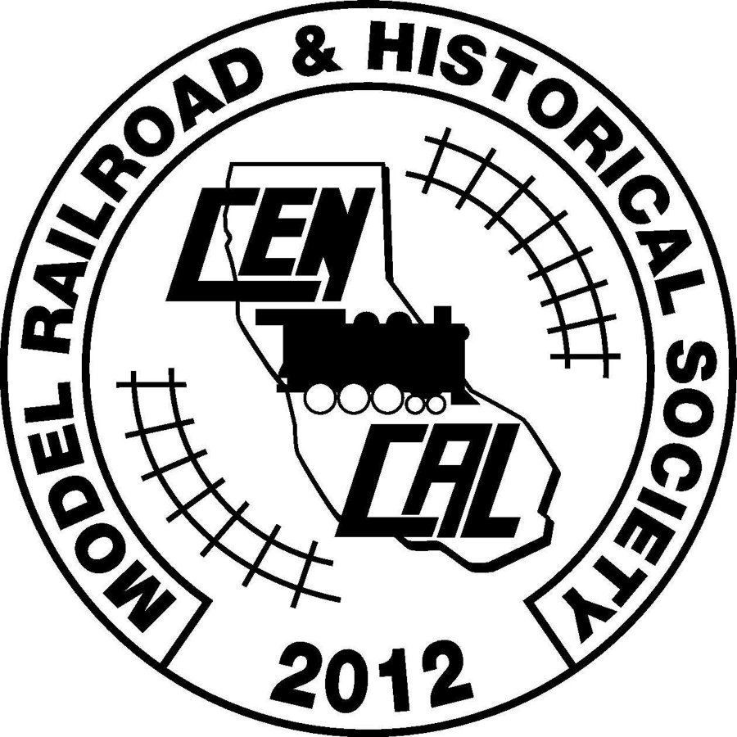

Central California Model Railroad
& Historical Society, Inc.
IRS 501 (c ) (3) Charitable Organization

Registration Form

Location: Porterville Historical Museum
257 North D Street, Porterville CA 93257
Setup: September 11th, 2026 Friday 10:00am -- 3:00PM
Setup: September 12th, 2026 Saturday 7:30am – 9:30am

Show: September 12th, 2026 Saturday 10:00am – 3:00PM

Vendor Name

Address

Phone #

Email

Number of Tables (Max 2)
We have 4 Tables (30" x 8') & 7 Tables (30” x 6’ approx..) -- ($10 per table)

Rules and Security will be enforced. All items for sale or trade must be toy or train related.
CCMRHS is not responsible for the loss or theft of your goods.
Name badges provided by CCMRHS must be worn at all times, and vendor name displayed.
All items must be on or under the tables. Do not block aisles. Vendors are expected to stay until closing time.
COVID/Health - Will observe all requirements in place at time of show. CCMRHS will provide hand sanitizer and masks if needed.

Information Contact: Frank Spina at email: fspina09@gmail.com or call: 559-361-9308

Return Registration Form and CA DEPARTMENT OF TAX AND FEE ADMINISTRATION FORM to:
Frank Spina
PO BOX 848
Springville, CA 93265-0848

