THE D STREET TRAIN SHOW 2024
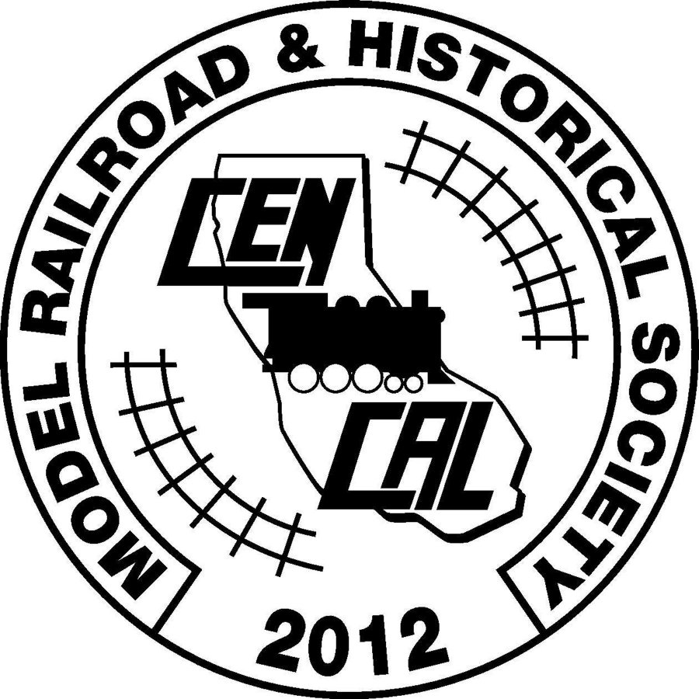

Central California Model Railroad
& Historical Society, Inc.
IRS 501 (c ) (3) Charitable Organization

Registration Form

Location: Porterville Historical Museum
257 North D Street, Porterville CA 93257
Setup: 17 May 2024 Friday 10:00am - 4:00PM
Setup: 18 May 2024 Saturday 7:30am – 9:30am

Show: 18 May 2024 Saturday 10:00am – 4:00PM

Vendor Name

Address

Phone #

Email

Number of Tables (Max 2)
We have 4 Tables (30" x 8') & 7 Tables (30” x 6’ approx..)- ($10 charge for a table)

Rules and Security will be enforced. All items for sale or trade must be toy or train related.
CCMRHS is not responsible for the loss or theft of your goods.
Name badges provided by CCMRHS must be worn at all times.
All items must be on or under the tables. Do not block aisles. Vendors are expected to stay until closing time.
COVID - Will observe all requirements in place at time of show. CCMRHS will provide hand sanitizer and masks if needed.

Information Contact: Rick Plummer at email: o.gauger@yahoo.com Or 559-924-9227

Return Registration Form and CA DEPARTMENT OF TAX AND FEE ADMINISTRATION FORM to:
Rick Plummer
380 S. 19th Ave
Lemoore, CA. 93245

